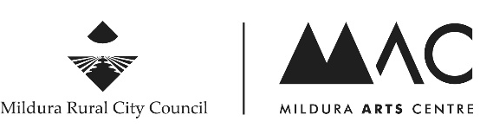
Mildura Rural City Council Artist Directory Listing Request
Artist name*:
Are you of Aboriginal and / or Torres Strait Islander origin? Yes: ___ No: ___
Visual Arts ___ Performing Arts ___ Literature ___ Other(s):

Statement (up to 80 words describing your practice):

Contact details*
Website / social media links:

Phone:
Email:
Postal address:

I acknowledge that the details supplied in this form will be published in Council’s Artist Directory, available at Mildura Arts Centre and online at milduraartscentre.com.au
I have made every effort to ensure all details supplied are accurate and correct. I acknowledge that details are subject to change and that it is my responsibility to notify Council about any updates, alterations or changes to ensure all published details are accurate. I acknowledge Council reserves the right to reject or remove Artist Directory listings at its discretion.
Signature*:

*only name, one method of contact, and signature required, everything else optional.

Please scan and email signed, completed form to: arts_centre@mildura.vic.gov.au
or post to: Mildura Arts Centre, PO Box 105, MILDURA VIC 3502

